27.56: a) Motion is circular:
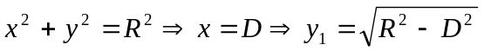 (path of deflected particle)
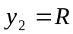 (equation for tangent to the circle, path of undeflected particle)
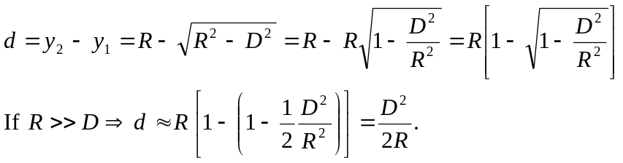
For a particle moving in a magnetic field, 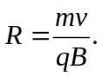
But 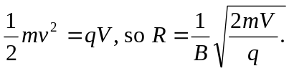
Thus, the deflection 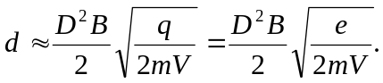
b) 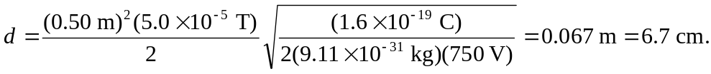
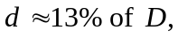 which is fairly significant.

